Proxy for pip
Enter Pip config command in command prompt
pip config set global.proxy http://proxy.nas.medcity.net:80
Contents of Pip.ini highlighted below
[global]
proxy = http://proxy.nas.medcity.net:80
References:
https://stackoverflow.com/questions/43473041/how-to-configure-pip-per-config-file-to-use-a-proxy-with-authentification

Proxy Settings for Visual Studio Code
Go to settings
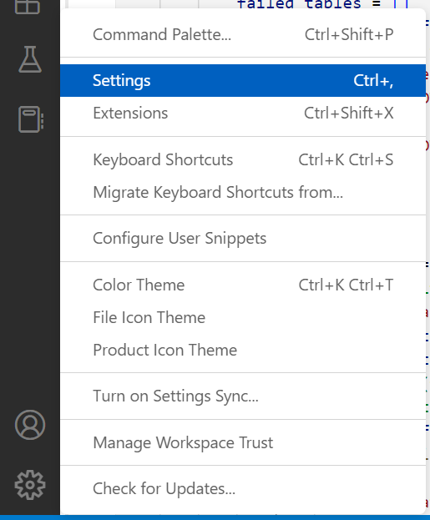
Search for proxy and set Http:Proxy to http://proxy.nas.medcity.net:80
